**University of Petroleum and Energy Studies**

School of Computer Science

Department of Cybernetics



**Graphics & Animation Tools**

**LAB FILE**

**(Session: 2020-2021)**

Course: B. Tech with Specialization in Open Source and Open Standards





**VIVA-ASSIGNMENT**

**1)Aim -** Create a logo of any water bottle brand.

**Steps followed-**

1. Open GIMP.
2. Inside gimp, create a new layer with white background(1080x1080 px).
3. Open an image of bottle as layers in GIMP and create a new transparent layer to draw water bottle.
4. Use the ‘Paths tool’ over the image and start selection boundaries and layout of the image.
5. After selection of layout/ boundaries, go to ‘Select’, choose ‘From Path’ option and your path will be selected.
6. After path is selected click on ‘bucket fill tool’ from the toolbar and color the bottle with your desired color.
7. Repeat step 3,4,5 for creating the cap of the water bottle.
8. Structure of water bottle is complete, now go to ‘Text tool’ and write name of the brand that you want for your bottle.
9. Use your creativity to style your text and when you feel it’s good, then place is at the desired location.
10. For adding the base/ table, cover the boundaries of the bottle and the white background using ‘Paths tool’ and then fill color in it using ‘bucket fill tool’.
11. Additional: Import logo of that brand and add it at the center of the bottle.

**Output:**

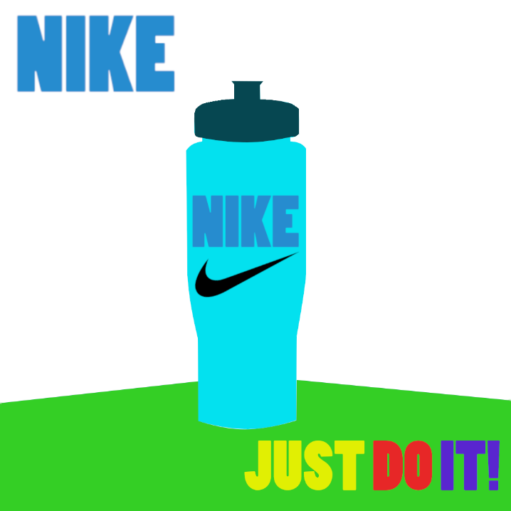

**2)Aim -** Create a hand sanitizer using blender

**Steps followed**-

1. Open Blender.
2. Clear everything from the interface.
3. Select mesh and then select a cylinder
4. Now extend the cylinder so it looks like bottle.
5. After add another cylinder.
6. Extend its length of the second cylinder.
7. Position this cylinder inside the outer cylinder to represent the straw inside the spray bottle.
8. Now using the knife tool cut a circle shape on top of the spray bottle to act as a straw holder.
9. Add a new cylinder and apply a solidify modifier to make it hollow. Position this hollow cylinder in contact to the outer cylinder and over the inner cylinder.
10. Copy and paste the previous hollow cylinder and position it above the previous one (over the inner cylinder representing straw).
11. Now add another and final cylinder. Scale the cylinder to represent the nozzle. Rotate the cylinder and fix it over the top most hollow cylinder.
12. Now for coloring, use blue for the bottle and green for nozzle.

**Output:**

